Invitation to Participate at Codefest Marathon 2016

The 4th edition of the tech event Codefest will take place on 15-17th April in Ohrid, Macedonia. It is a developed form of what was known so far as a coding marathon for tech students, who can develop their ideas within 32 marathonic hours, from scratch. This year the event joins together all the sides of the tech community, not only students, high schoolers and IT professionals, but also the IT business sector, the educational sector, startups and investment funds. The event will take place at Hotel INEX Gorica in Ohrid.
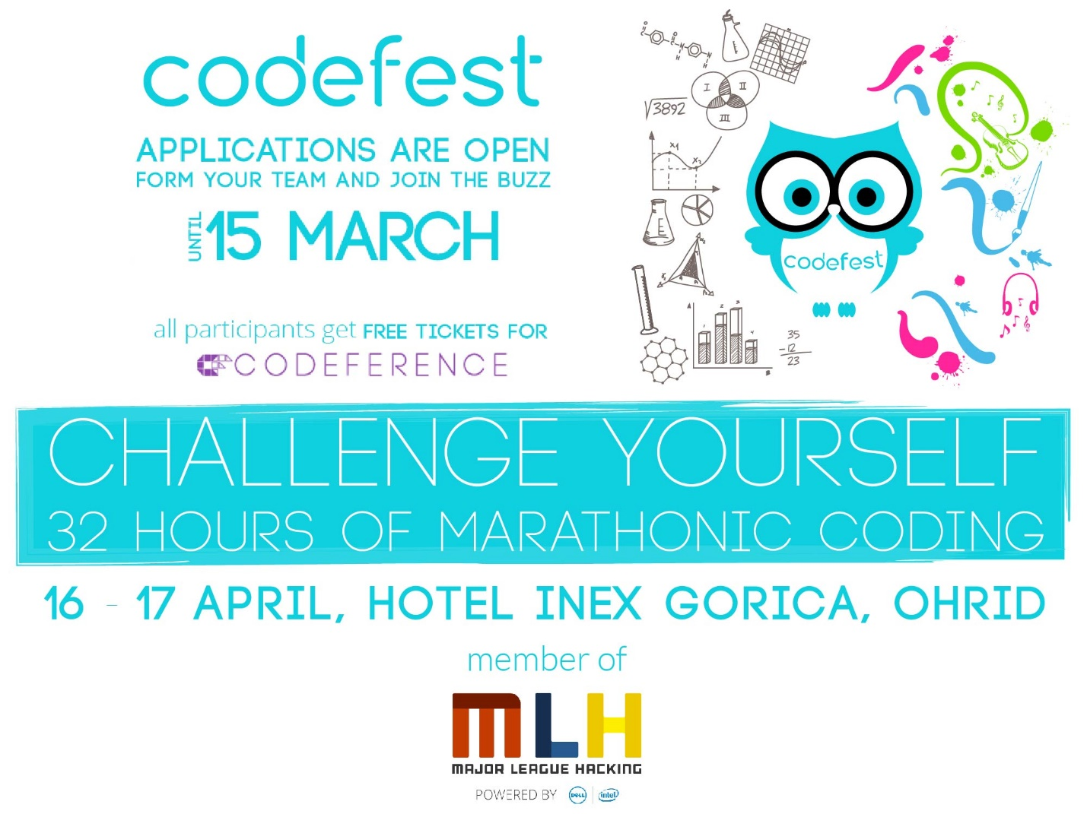
To apply for Codefest Marathon, you should register using the following link:
http://codefest.eu/marathon#Register
The registration rules include:
- You should be a student (high school, undergrad or masters) and to have a valid proof for that
- You should form a team of 2-5 members
- You should apply with a creative and innovative idea with good business potential
- You should not have done any work on this idea before the event, or you will be disqualified (the challenge is to develop a demo or prototype version of the idea, from scratch, within the marathon duration of 32 hours).
The application deadline is March 15th, 2016. Participation at Codefest Marathon is completely free from any fees for all selected teams.

For more information and any questions you might have regarding Codefest Marathon, please check the FAQs folder on Facebook. Also, join the Facebook event to be finding out any updates and news.
This year Codefest Marathon has a strong international character, being an official member of the global hackathons league, Major League Hacking. With this, the participating teams will get extended international visibility, and there will also be global recognition for the best teams.
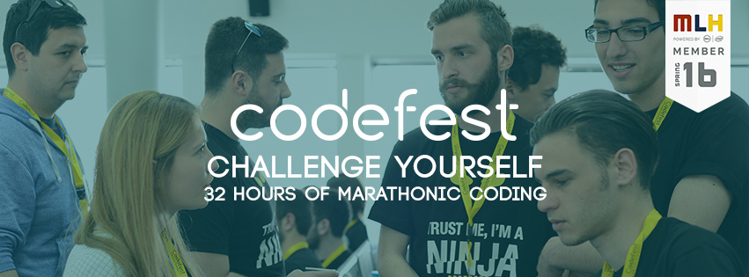

All selected participants for Codefest Marathon will get free entrance tickets to Codeference – a one-day tech conference that will take place on April 15th, as well as full access to the CFX-Business Expo that will take place in parallel with everything.

